# PRACTICE PROGRAM MODULE 4

## SECTION-4.2

4.

**PROGRAM:**

package harini1;

import java.util.Scanner;

public class Student

{

private String fName;

private String lName;

private String stuId;

private String stuStatus;

public Student(String fName, String lName, String stuId, String stuStatus)

{

this.fName = fName;

this.lName = lName;

this.stuId = stuId;

this.stuStatus = stuStatus;

}

public void displayStudentInfo()

{

System.***out***.println("Student Name: " + fName + " " + lName);

System.***out***.println("Student ID: " + stuId);

System.***out***.println("Student Status: " + stuStatus);

}

public static void main(String[] args)

{

Student student = new Student("Lisa", "Palombo", "123456789", "Active");

student.displayStudentInfo();

}

}

**CODE:**

Student Name: Lisa Palombo

Student ID: 123456789

Student Status: Active

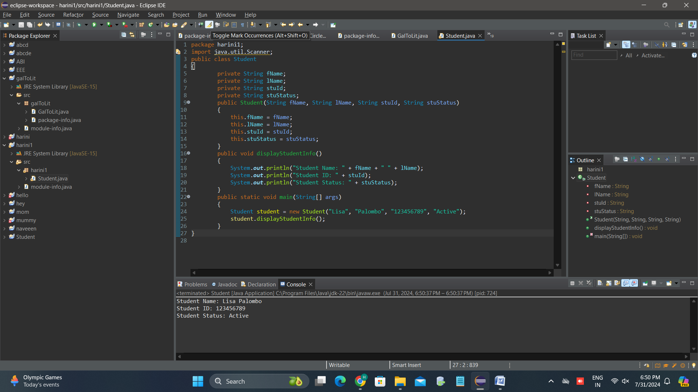

5.

**PROGRAM:**

package harini1;

import java.util.Scanner;

public class Driver

{

public static void main(String[] args)

{

Student student = new Student("Lisa", "Palombo", "123456789", "Active");

student.displayStudentInfo();

}

}

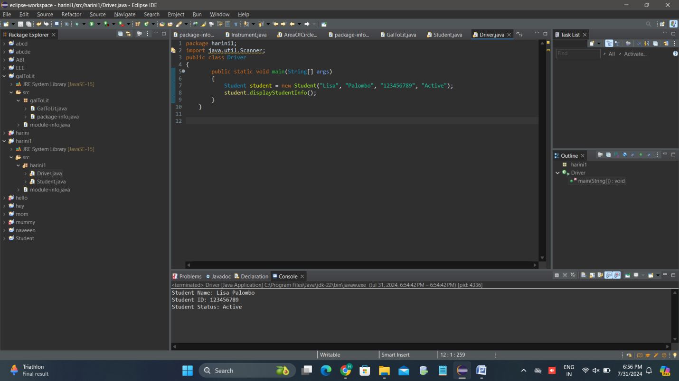

**7.COMPLETE THE CODE**

package harini1;

import java.util.scanner;

public class Person

{

private String name;

private int age;

public Person(String name, int age) {

this.name = name;

this.age = age;

}

public String getName() {

return name;

}

public int getAge() {

return age;

}

public void setAge(int age) {

this.age = age;

}

}

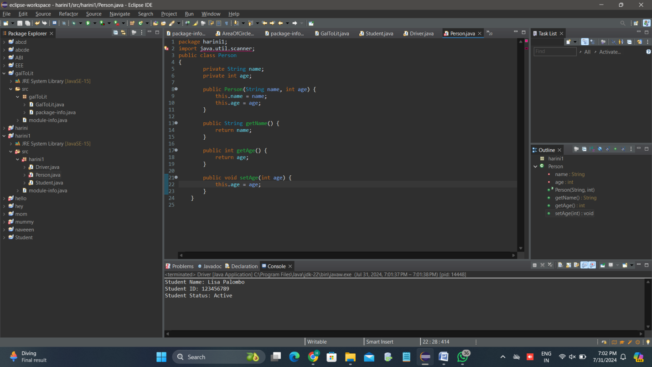

8.

PROGRAM CODE:

package student;

import java.util.Scanner;

public class Person {

private String name;

private int age;

public Person(String name, int age) {

this.name = name;

this.age = age;

}

public String getName() {

return name;

}

public int getAge() {

return age;

}

}

public class ManagingPeople {

public static void main(String[] args) {

Person p1 = new Person("Arial", 37);

Person p2 = new Person("Joseph", 15);

if (p1.getAge() == p2.getAge()) {

System.***out***.println(p1.getName() + " is the same age as " + p2.getName());

} else {

System.***out***.println(p1.getName() + " is NOT the same age as " + p2.getName());

}

}

}

}